# CMAPS
***
## General Info
To identify crime hotspots for the data collected from Lahore, in attempt to aid police officials reduce crime and improve the standard of living.
## Technologies
***
- [Andriod Studio ]( https://developer.android.com/studio): Version 3.6.3
- [Java JDK]( https://www.oracle.com/java/technologies/javase-downloads.html): Version 14.0.2
- [Dexter]( https://github.com/Karumi/Dexter): Version 6.2.2
## Installation
***
Install emulator from AVD Manager Window

## Collaboration
***
Select emulator from menu bar
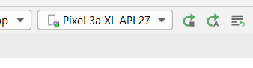

- Open command prompt and run command
- “ ipconfig “
- Copy Ipv4 Address
- 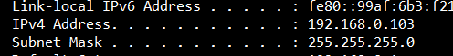
- Replace the address in url link with Ipv4 address of your network :Local host address
- 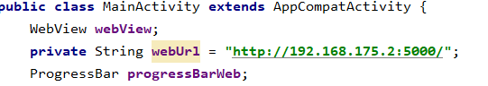
- Run the project by selecting Run Button
##To Run on Android Device
- Open settings
- Click 7 8 times on build number
- Developer mode will be enabled
- Enable usb debugging too
- Connect your android device with PC
- Allow file sharing
- Select your device from menu bar
- Select run button

